Project number | Grant 956649
Country
Lead contractor
Authors | Stefano Dotta
Date | 21/04/2023
More information | More details about the “EUROPA” project is available online at www.europa.com and from project coordinators.

Disclaimer
This publication does not necessarily represent the opinion of the European Community and the European Community is not responsible for any use that might be made of data appearing therein. Access to and use of the contents in this publication is at the user‘s own risk. Damage and warranty claims arising from missing or incorrect data are excluded. The authors bear no responsibility or liability for damage of any kind, also for indirect or consequential damages resulting from access to or use of this publication.
Contents

1. FOREWORD 4
2. INTRODUCTION 4
3. FRENCH OSS BUSINESS MODEL CANVAS 5
3.1. Customer Segments (max. 2000 characters including spaces) 6
3.2. Value Proposition (max. 2000 characters including spaces) 6
3.3. Channels (max. 2000 characters including spaces) 6
3.4. Customer Relationship (max. 2000 characters including spaces) 6
3.5. Revenue Streams (max. 2000 characters including spaces) 6
3.6. Key Resources (max. 2000 characters including spaces) 7
3.7. Key Activities (max. 2000 characters including spaces) 7
3.8. Key Partners (max. 2000 characters including spaces) 7
3.9. Cost Structures (max. 2000 characters including spaces) 7
4. GERMAN OSS BUSINESS MODEL CANVAS 8
4.1. Customer Segments (max. 2000 characters including spaces) 9
4.2. Value Proposition (max. 2000 characters including spaces) 9
4.3. Channels (max. 2000 characters including spaces) 9
4.4. Customer Relationship (max. 2000 characters including spaces) 9
4.5. Revenue Streams (max. 2000 characters including spaces) 9
4.6. Key Resources (max. 2000 characters including spaces) 10
4.7. Key Activities (max. 2000 characters including spaces) 10
4.8. Key Partners (max. 2000 characters including spaces) 10
4.9. Cost Structures (max. 2000 characters including spaces) 10
5. ITALIAN OSS BUSINESS MODEL CANVAS 11
5.1. Customer Segments 12
5.2. Value Proposition 12
5.3. Channels 12
5.4. Customer Relationship 13
5.5. Revenue Streams 13
5.6. Key Resources 14
5.7. Key Activities 14
5.8. Key Partners 15
5.9. Cost Structures 16
6. LATVIAN OSS BUSINESS MODEL CANVAS 17
6.1. Customer Segments 18
6.2. Value Proposition 18
6.3. Channels 19
6.4. Customer Relationship 19
6.5. Revenue Streams 19
6.6. Key Resources 20
6.7. Key Activities 20
6.8. Key Partners 20
6.9. Cost Structures 21
7. PORTUGUESE OSS BUSINESS MODEL CANVAS 22
7.1. Customer Segments 23
7.2. Value Proposition 23
7.3. Channels 24
7.4. Customer Relationship 24
7.5. Revenue Streams 24
7.6. Key Resources 25
7.7. Key Activities 25
7.8. Key Partners 26
7.9. Cost Structures 27

FOREWORD
The Business Models of the five regional One Stop Shop have been prepared by Europa Partners. Europa is a project funded by Horizon 2020 Programme of the European Union and aim to promote and boost the implementation of deep energy renovation in the residential building sector by building trust on the market, triggering new investment and setting up standards and specifications to guarantee their performance

INTRODUCTION
A specific business model in order to describe the OSS value proposition, and secure the sustainability of the project experience in the future has been developed for each of the regions involved. A common approach was defined during the project in a specific mutual learning meeting (T5.2) that took place on line on Tuesday, June 14th,2022.
The common methodology to define the OSS sustainability was the business model canvas a tool created by Alex Osterwalder to describe, analyze and design, with a visual representation, the business models and rationale of how an organization creates, delivers and captures value.

To implement an OSS that can last, it is necessary to define an understandable business model, trying to describe in a simple way how it works and its complexities. The business model canvas enables this simplification and will allow partners to describe their OSS model in a simple way and in a clear, internationally shared language.
Thanks to the BMC, each OSS can be described through the following nine basic blocks that illustrate its operating logic:
- Customer Segments define the different groups of people or organizations OSS aims to reach and serve. Who is your target audience? How can you meet their needs?
- Value Proposition describes the bundle of products and services provided by OSS that create value for a specific Customer Segment. How will you make your customers’ life happier? How do you stand out from competition? What’s your value add?
- Channels describes how an OSS communicates with and reaches its Customer Segments to deliver Value Proposition. How are you going to reach your customers?
- Customer Relationship describes the types of relationships a n OSS establishes with specific Customer Segments. How often will you interact with your customers?
- Revenue Streams represents the cash an OSS generates from each Customer Segments (costs must be subtracted from revenues to create earning). How much are you planning to earn in a certain period? Compare your costs and revenues.
- Key Resources describes the most important assets required to make a business model work. What resources do you need to make your idea work?
- Key activities describe the most important things a company must do to make its business model work. What are the key steps to move ahead to your customers?
- Key Partners describes the network of suppliers and partners that make the business model work. What are your key partners to get competitive advantage?
- Cost Structure describes all costs incurred to operate a business model. How much are you planning to spend on product development and marketing for a certain period?
All of the above nine building blocks were developed by each regional partner into a specific business model for its OSS and reported in the following chapters.

FRENCH OSS BUSINESS MODEL CANVAS
A specific Business Model Canvas has been defined by AGEDEN in order to describe the French OSS .

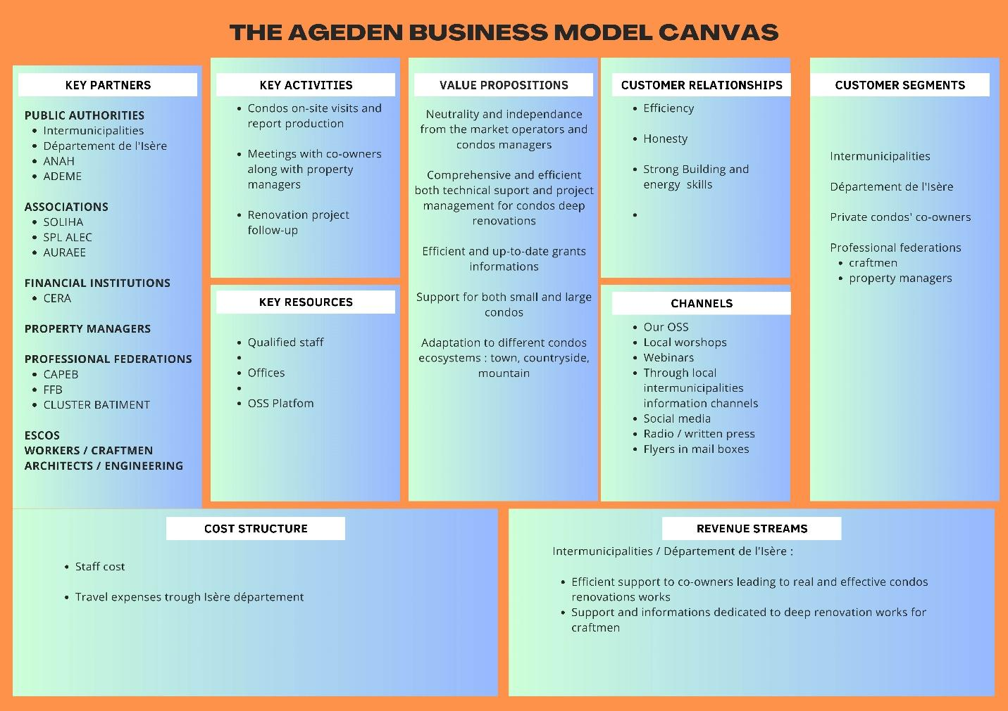

Picture 1 French OSS Business Model Canvas

Customer Segments (max. 2000 characters including spaces)
Our OSS provides value to the following customer segments :
- Intermunicipalities of Isère and the Isère Département by itself. These public authorities have mandatory actions to deliver for the population through the “PCAET”, which is a “Climate, Air, Environment and Territorial Plan”. Part of this plan is dedicated as lodging renovation support. AGEDEN is thus one of the operational actors to deliver this support to the population.

Value Proposition (max. 2000 characters including spaces)
The main inputs regarding our value proposition are:
· Neutrality and independence from the market operators and condos managers. This is very important to us to be completely independent from the market as we must be trusted by the end-users to deliver honest data and tackle part of the fear and anxiety generated by this long term project.
· Comprehensive and efficient both technical support and project management for condos deep renovations: At least half of a deep renovation project success is linked to project management and human relationships management.
· Efficient and up-to-date grants information: the French grants system is very and regularly changing so up-to-date information is critical.
· Support for both small and large condos & adaptation to different condos ecosystems such as town, countryside and mountain. We want to offer the same level of quality support wherever the co-owners are located and whatever the type of condos they live in.

Channels (max. 2000 characters including spaces)
Our communication channels are the following ones:
- Our website
- Local workshops and webinars
- Through local intermunicipalities information channels
- Social media
- Radio & written press

Customer Relationship (max. 2000 characters including spaces)
We build our customer relationships upon three main values and skills : Efficiency, Honesty and Strong Building and energy skills. These elements are essential to build trust in our ability to provide the condos’ co-owners relevant information in our report (technical data and grants information) and in our capacity of helping them to drive their deep renovation project on a long term.

Revenue Streams (max. 2000 characters including spaces)
AGEDEN is getting money from Intermunicipalities and Isère Département for two main activities which are:
- Efficient support to co-owners leading to real and effective condos renovations works
- Support and informations dedicated to deep renovation works for craftsmen

Key Resources (max. 2000 characters including spaces)
As already detailed before, our main strength is our qualified and experienced staff who has both technical and human relationships skills. As the Isère department is quite large, our two offices located in the north and south of the department are also part of our key resources. That enables us to be close to the field and available for onsite support and regular meetings with the co-owners.

Key Activities (max. 2000 characters including spaces)
To trigger a deep renovation project we have identified and set up these key activities :
- Condos on-site visits and report production: this first step is mandatory as it is required to have data and knowledge about the building and its use to be able to provide proper support.

- Meetings with co-owners along with property managers: time must be spent to identify blockades and fears in order to tackle them and the deep renovation project possible

- Renovation project follow-up: as any condominium renovation project requires many years to be set up properly, the follow-up is essential otherwise the project could collapse.

Key Partners (max. 2000 characters including spaces)
AGEDEN key partners for our OSS are the following ones:
- PUBLIC AUTHORITIES
  - Intermunicipalities
  - Département de l'Isère
  - ANAH (national public authority)
  - ADEME (national public authority)

- ASSOCIATIONS (national, regional and local)
  - SOLIHA
  - SPL ALEC
  - AURAEE

- FINANCIAL INSTITUTIONS

- PROPERTY MANAGERS

- PROFESSIONAL FEDERATIONS
  - CAPEB
  - FFB
  - CLUSTER BATIMENT

- ESCOS

- WORKERS / CRAFTSMEN

- ARCHITECTS / ENGINEERING

They all do represent a part of the chain value (and complexity) of the deep renovation process of private condos.

Cost Structures (max. 2000 characters including spaces)
The main costs of our one-stop-shop are the following ones:
- Staff cost for both technical and communication teams ;
- Travel expenses;
- Communication

GERMAN OSS BUSINESS MODEL CANVAS
A specific Business Model Canvas has been defined by eza! in order to describe the German OSS .

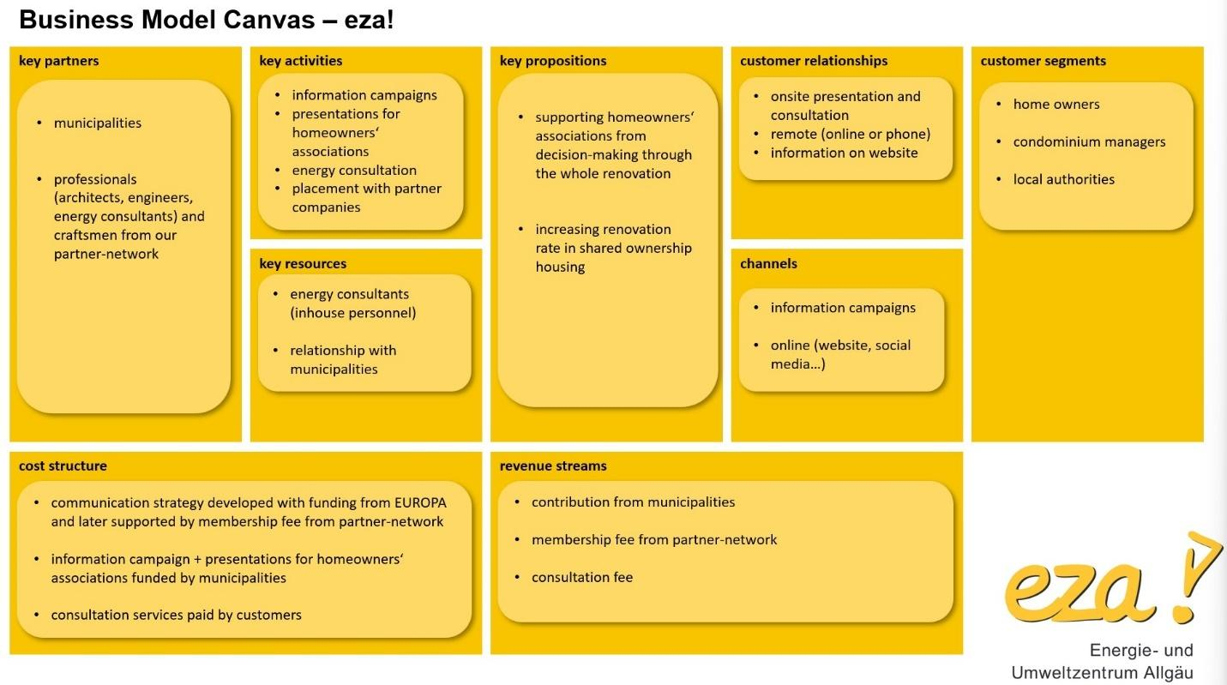

Picture 2 German OSS Business Model Canvas

Customer Segments (max. 2000 characters including spaces)
The German OSS focuses on three customer segments:
- homeowners within condominiums who are interested in energy renovation and who need support to inform and motivate their co-owners/neighbours and technical support throughout the renovation process from design to funding and implementation and connection with the professionals from the OSS’s network
- condominium managers who are tasked with weighing renovation measures for the buildings they manage and who need technical support to help them throughout the renovation process from design to funding and implementation
- local authorities with whom the OSS will work together to provide information services aimed at their inhabitants and facilitate the implementation of renovation measures in condominiums

Value Proposition (max. 2000 characters including spaces)
By focusing on condominiums we aim to increase the renovation rate within that target group. Because of the difficult decision making in the co-ownership setting, condominiums are up to now less noticed by consultants and interest in renovation by individual owners is often stifled by lack of information and support before other owners can be motivated.
We want to provide a full service offer, facilitate decision making and support throughout the whole renovation project.

Channels (max. 2000 characters including spaces)
For communication we will use
- Advertisement by mail or newspaper for the information events in the municipality and to promote the individual presentations
- Our website for information, technical and legal material
- Social media to promote events

Customer Relationship (max. 2000 characters including spaces)
To strengthen customer relationships we will provide most of our services on-site or at least in the municipality. Most important will be the presentations for the homeowners’ association to promote the necessary share of participation and facilitate decision making by equally informing all owners.
Follow-up consultation activities will consist of on-site visits and communication by mail and phone.

Revenue Streams (max. 2000 characters including spaces)
The information activities of the OSS will be funded partly by the municipalities, leaving a deductible for the condominiums.
Further consultation and inspection of the buildings will be billed to the condominiums directly.
The membership fee from our partner network will support background activities and further development of the services provided.

Key Resources (max. 2000 characters including spaces)
Key resources include
- the energy consultants necessary for providing high quality services to the condominiums
- the relationship with municipalities and local authorities in order to work together and receive funding for the services offered

Key Activities (max. 2000 characters including spaces)
Key activities will revolve around the information campaign launched with the municipality:
- Information campaign, consisting of larger events in the municipality and/or advertisement for
- individual presentations for the homeowners’ associations to promote the necessary share of participation and facilitate decision making by equally informing all owners
- Energy consultation for individual buildings, recording the status quo and recommending appropriate renovation measures, support throughout the renovation process from design to funding and implementation
- Placement with qualified partner companies from our network to ensure the energy quality of the work carried out

Key Partners (max. 2000 characters including spaces)
Key partners are:
- The municipalities. Their backing and support will ensure sustainability of our activities but also provide a sense of authority and safety to our campaigns.
- The professionals and craftsmen from our partner-network. The demand exceeding the capacities of the OSS in consultation will be absorbed by the network. Practical implementation by qualified market operators from the network ensures customer satisfaction and will help to increase demand for the services provided by the OSS.

Cost Structures (max. 2000 characters including spaces)
The initial services will be developed with funding from project EUROPA. This includes the communication strategy and a template for the presentations. The working hours for the information campaign and presentations will be backed by municipalities and a deductible from the condominiums. Consultation services provided will be paid by the condominiums.
Further development of services can be supported by the membership fee from our partner network.

ITALIAN OSS BUSINESS MODEL CANVAS
A specific Business Model Canvas has been defined by Environment Park in collaboration with Regione Piemonte in order to describe the Italian OSS .

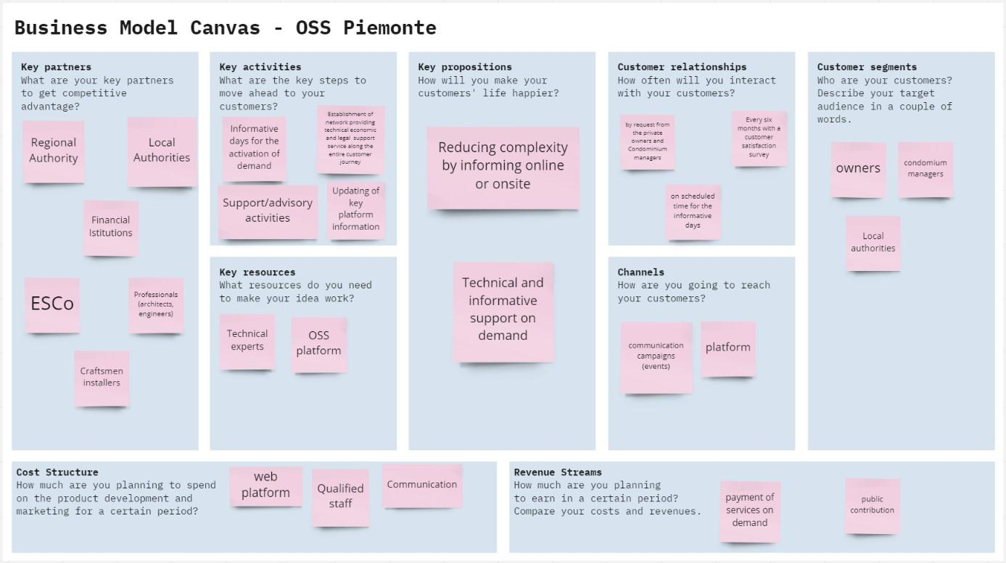

Picture 3 Italian OSS Business Model Canvas

Customer Segments
The Italian OSS aims to provide services to three potential customers:
· Owners of buildings/condominiums/apartments who intend to undertake energy renovation work and who need technical support to help them throughout the process from design to implementation and monitoring of the expected energy saving results
· Condominium managers who intend to undertake energy requalification work on the buildings they manage and who need technical support to help them throughout the process from design to implementation and monitoring of the expected energy saving results
· Local authorities to which the OSS could provide training and information services aimed at their inhabitants and facilitate the implementation of energy upgrading measures in private buildings by connecting them with the network of companies and professionals

Value Proposition
The Italian One Stop Shop aims to reduce the complexity of the energy requalification process of private buildings, in particular condominiums, by offering a number of services to its clients.
The Italian OSS can be included among the OSS models defined as advice model or support model as the services offered mainly concern, Information/Marketing, Detection, Simplified diagnosis and recommendations, selection of companies financial plan
These services can be provided by the OSS through technical and informative support on demand or through the web platform.
On the other hand, the Italian OSS cannot be considered as an implementation model as it does not offer financial products, worksite supervision or reception of the work, nor quality assurance, guarantees and follow up.

Channels
With the aim of reaching its customers by presenting the services and initiatives offered by the OSS, it plans to use various information channels:

· The https://www.sportelloenergia.envipark.com/ web platform tested during the EUROPA project allows customers to contact the OSS, find useful information, request appointments and activate services
· Communication campaigns using Piedmont Region and Environment Park institutional channels (websites, newsletters, press releases, social media, etc.).
· Events organized in collaboration with key partners in order to reach owners and condominium managers. These events may be organized in the form of informative days in cooperation with municipalities
This variety of channels will make it possible to reach OSS customers through different forms of communication both online and in-presence through events. The proposals and information may also be different depending on the communication channel used, in some cases they will simply be communications or information disseminated in other cases they will be services provided.

Customer Relationship
The Italian OSS interacts at different time with its customers depending by the service provided:
· At the request of private owners and condominium managers if the OSS provides an advisory service (meetings, phone calls, emails)
· On scheduled time for the informative days organized in collaboration with municipalities and key partners
· Every six months with a customer's satisfaction survey. This activity is very important to improve the services offered and to keep them in line with customer expectations and market demands

Revenue Streams
The Business Model Canvas of the Italian OSS provides that financial sustainability is ensured by two types of revenues.

· The first source of revenue comes from public contributions and can be provided in different forms
o From the Piedmont Region in order to guarantee the maintenance of the basic services offered by the OSS such as the information services provided through the web platform. The regional contributions will make it possible to keep the platform up-to-date and to respond to any requests and queries through e-mail or call centres.
o From Municipal administrations could request additional services through a subscription fee. These services could concern more in-depth forms of support to citizens or the organisation of a certain number of information days on their territory
· The second source of revenue come from owners or condominium administrators in the case of detailed advice provided through meetings or back-office activities

Key Resources
The resources needed for the functioning of the Italian OSS are of three types, the first concerns human resources while the second concerns technical and IT equipment, the third concerns communication tools
· Human resources. Environment Park will provide the OSS with technical experts, in particular engineers with experience in energy efficiency and renewable energy, and architects with experience in deep renovation of buildings, as well as expert for economic and financial simulations
· Equipment.
o Technical equipment needed for energy audits (thermal flow meter, thermal imaging camera. electric network analyser, etc.)
o Web platform
· Communication resources. Piedmont Region and Environment Park will provide their communication tools to make the OSS work (see channel section).

Key Activities
The Key activities provided by the Italian OSS are:
· Updating key platform information. The web platform is the first landing place for the customers, for this reason it is important to keep the platform up-to-date with useful information for users such as incentive mechanisms, funding opportunities, technical information, lists of professionals and companies in the network.
· Informative days for the activation of demand. At the request of municipalities, information days may be organized to present new financial and incentive opportunities to groups of owners or condominium managers. These informative days may also have a more technical purpose and be aimed at setting up purchasing groups or presenting products or technological solutions for the energy requalification of buildings.
· Support/advisory activities. The OSS also provides consultancy support on specific projects, this type of activity is delivered through face-to-face meetings and through the preparation of documents or energy analyses (e.g. energy audits)
· Establishment of network providing technical economic service along the entire customer journey

Key Partners
In order for the OSS to function in the best possible way, it is necessary for it to fit into a context of relations with the main local and regional actors and stakeholders. For this reason, one of the OSS's objectives is to set up and maintain a network to which the OSS's key partners adhere and they are:
· Regional Authorities. The Piedmont Region is the main key partner as it promoted the establishment of the OSS and considers it a strategic tool for promoting energy efficiency and reducing consumption in private buildings
· Local Authorities. Municipalities are a key partner as they can promote the activities of the OSS among their citizens. They can request the activation of specific information services such as information days and financially support the OSS
· Market operators (ESCo, construction companies. etc.). They are a key partner of the OSS network. Owners require the OSS to provide lists of reliable market operators who guarantee quality work and on time.
· Professionals. They are a key partner of the OSS network. Owners require the OSS to provide lists of reliable professionals who guarantee experience and competence
· Craftsman/installers. They are a key partner of the OSS network. Owners often require the OSS to provide lists of reliable craftsmen who guarantee experience and competence.
· Financial Istitutions. They are a key partner of the OSS network. Owners often require the OSS to provide lists of financial institutions who can provide loan for their investments.

Cost Structures
The basic costs that the Italian one-stop-shop faces are the following:
- Personnel expenses;
- Infrastructure expenses for IT systems;
- Maintenance of web platform
- Equipment
- Travel expenses;
- Marketing and advertising expenses;
- Communication

LATVIAN OSS BUSINESS MODEL CANVAS
A specific Business Model Canvas has been defined by Ekubirojs in order to describe the Latvian OSS .

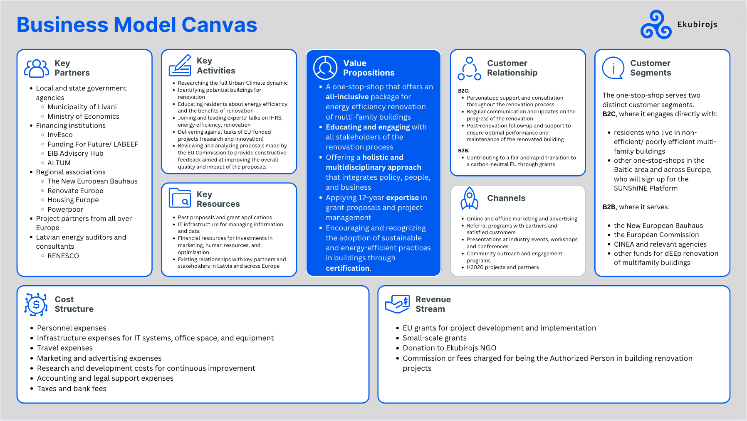

Picture 4 Latvian OSS Business Model Canvas

Customer Segments
The Ekubirojs one-stop-shop serves two distinct customer segments in Latvia. Its services are directed to key customers (B2C), which mostly comprise of both:
- residents who live in non-efficient/ poorly efficient multi-family buildings in Latvia; and
- other one-stop-shops in the Baltic area and across Europe, who will sign up for the SUNShINE Platform and adopt an EUROPA-like approach.
In addition, the Ekubirojs one-stop-shop engages in Business to Business (B2B) activities, by serving and collaborating with EU entities, such as:
- the New European Bauhaus;
- the European Commission;
- CINEA and relevant agencies; and
- other funds for dEEp renovation of multifamily buildings.

Value Proposition
The Ekubirojs one-stop-shop offers an all-inclusive package for energy efficiency renovation of multi-family buildings in Latvia from being the initial point of contact for the key customers to acting as Authorised Person on behalf of homeowners throughout the renovation process, to monitoring and evaluating the renovation projects in the long-term (15+ years). The Ekubirojs non-profit has been participating in grant proposals and proactively leading and managing projects for 12 years, while educating and engaging with all stakeholders of the renovation process offering a holistic and multidisciplinary approach that integrates policy, people, and business. In order to encourage and recognise the adoption of sustainable and energy-efficient practices in buildings across Latvia, the Ekubirojs one-stop-shop has constantly monitored the certification of energy efficiency service providers. Due to the novelty of one-stop-shops and integrated home renovation services (IHRS), there are no set up one-stop-shops in Latvia apart from Ekubirojs. Being the first and only one-stop-shop represents both an opportunity and a threat. Ekubirojs can definitely set up the standards high and be the solution for increased engagement between local municipalities, energy agencies, and residents. At the same time, the current regulatory and legislative framework in Latvia does not favor/foster building renovation in the country and does not even make energy efficiency retrofits accessible for all. Therefore, Ekubirojs has been facing challenges lobbying Latvian policy-makers and pushing residents to engage in the dialogue.

Channels
The Ekubriojs one-stop-shop has been using both traditional and digital channels for awareness-raising and promotional purposes. Among the key channels, there are:
- Online and offline marketing and advertising (social media, google ads, local radio, local newspapers - Leta.lv, tent days, flyers);
- Referral programs with partners and satisfied customers (discount);
- Presentations at industry events, workshops and conferences at local and regional levels;
- Community outreach and engagement programs (tent days, internship programs); and
- H2020 projects and partners.

Customer Relationship
The customer relationship that the Ekubirojs one-stop-shop has differs based on the key customers, both residents/one-stop-shops and EU entities/businesses. For the first group (B2C), the one-stop-shop offers:
- Constant personalized support and consultation throughout the renovation process;
- Regular communication and updates on the progress of the renovation; and
- Post-renovation follow-up and support to ensure optimal performance and maintenance of the renovated building (15+ years).
For the second group (B2B), the Ekubirojs one-stop-shop engages with EU entities and businesses (service providers in the energy efficiency field) with the aim of contributing to a fair and rapid transition to a carbon-neutral EU through grants, which is a shared goal/vision.

Revenue Streams
The Ekubirojs one-stop-shop has been trying to create as many revenue streams as possible to ensure all costs are covered and to guarantee good service performance. Since its setup, the main revenue streams of the one-stop-shop have been the following:
- EU grants for project development and implementation (EU-funded projects);
- Small-scale grants
- Donation to the Ekubirojs non-profit
- Commission or fees charged for being the Authorized Person in building renovation projects (up to 2% of the total renovation costs).

Key Resources
The most important assets required to make the Ekubirojs one-stop-shop’s business model work are:
- Past proposals and grant applications, which provided Ekubriojs with expertise and resources to implement key activities;
- IT infrastructure for managing information and data (a set of defined procedure in place to identify all phases of the building renovation process and all the engagement touchpoints with the different stakeholders of the process; the SUNShINE Platform as a project management tool to monitor the course/status of the renovation projects);
- Financial resources for investments in marketing, human resources, and optimization; and
- Existing relationships with key partners and stakeholders in Latvia and across Europe.

Key Activities
The key activities of the Ekubirojs non-profit and one-stop-shop that make the defined business model work in Latvia are:
- Researching the full Urban-Climate dynamic in Latvia;
- Identifying potential buildings for renovation and neighborhoods for awareness-raising initiatives;
- Educating residents about energy efficiency, the difference between ‘insulation’ and ‘renovation with energy efficiency’, as well as the benefits of renovation together with key stakeholders (local municipalities and energy agencies);
- Joining and leading experts' talks on IHRS, energy efficiency, renovation at both local and regional levels;
- Delivering against tasks of EU-funded projects (research and innovation, implementation of renovation projects through demo sites, lobbying activities); and
- Reviewing and analyzing proposals made by the EU Commission to provide constructive feedback aimed at improving the overall quality and impact of the proposals.

Key Partners
For the Ekubirojs one-stop-shop’s business model to be sustainable and effective, partnerships, collaboration agreements, Memorandum of Understandings play a key role. The one-stop-shop has connected with both local and regional actors and non-state actors, including project partners from all over Europe, to ensure that its key activities can be carried out correctly:
Local and state government agencies:
- Municipality of Livani
- Ministry of Economics
Financing institutions:
- InvEsco
- Funding For Future/ LABEEF
- EIB Advisory Hub
- ALTUM
Member of regional associations:
- The New European Bauhaus
- Renovate Europe
- Housing Europe
- Powerpoor
Latvian energy auditors and consultants
- RENESCO

Cost Structures
The basic costs that the Ekubriojs one-stop-shop faces are the following:
- Personnel expenses;
- Infrastructure expenses for IT systems, office space, and equipment;
- Travel expenses;
- Marketing and advertising expenses;
- Research and development costs for continuous improvement;
- Accounting and legal support expenses; and
- Taxes and bank fees.

PORTUGUESE OSS BUSINESS MODEL CANVAS
A specific Business Model Canvas has been defined by ARENATejo in order to describe the Portuguese OSS .

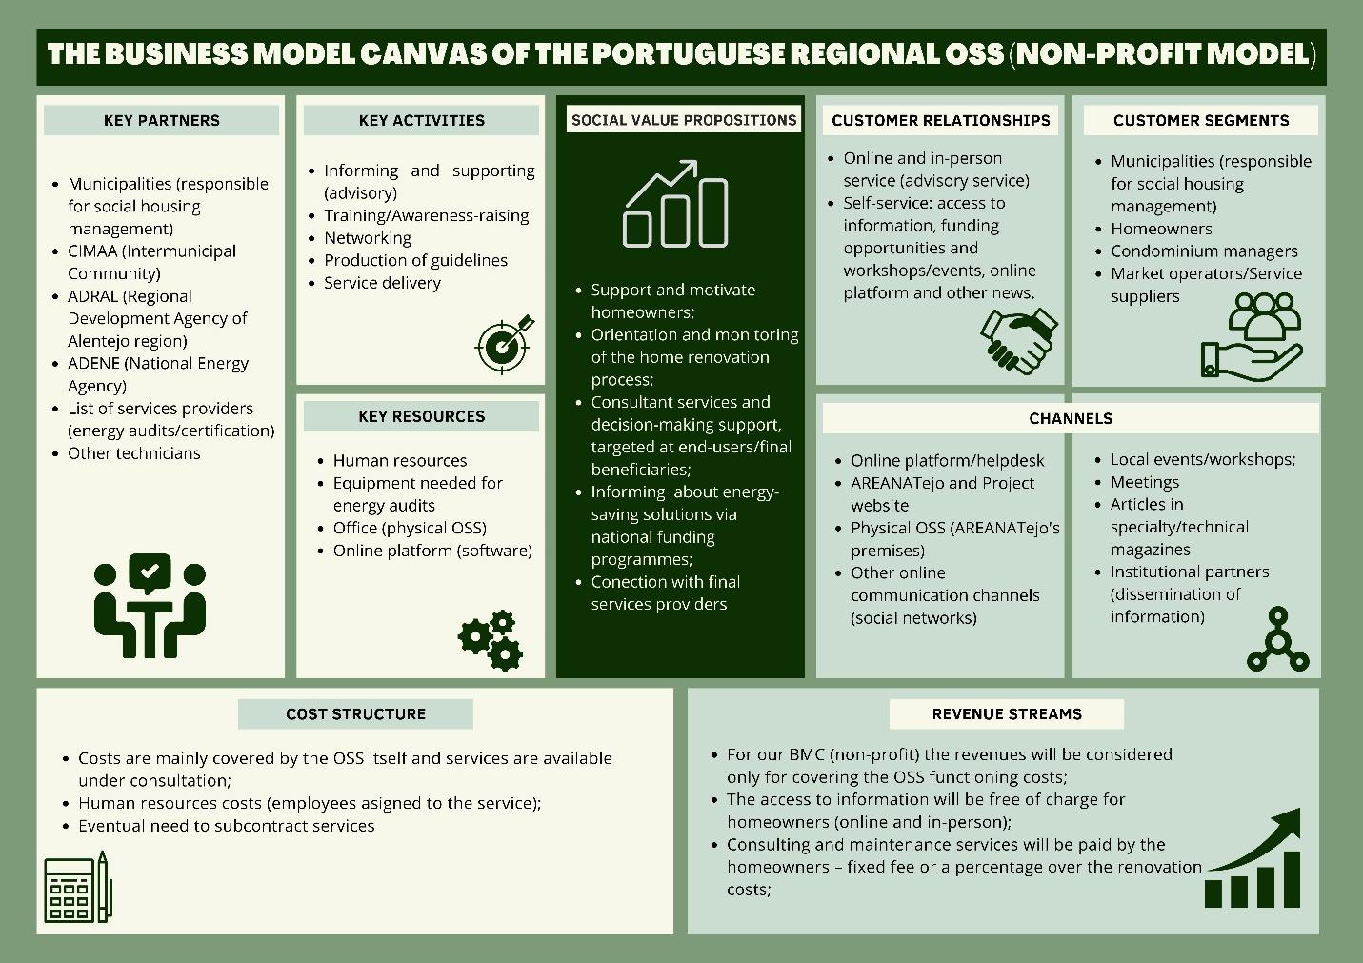

Picture 5 Portuguese OSS Business Model Canvas

Customer Segments
The Portuguese Regional One-Stop-Shop is targeted at the renovation of residential and social housing buildings in Alto Alentejo sub-region (Portugal).
Our approach is based on how the OSS creates value while delivering products or services for three distinct and main customer segments:
- Municipalities (responsible for social housing management), with whom AREANATejo established Collaboration Protocols;
- Customers (homeowners and condominium managers, the latter with few expression in our region) with with needs in terms of energy renovation of their houses and/or improvement of their thermal comfort;
- Market Operators/Service suppliers, with whom we usually work when specialized technical services are required, with the aim of engaging them in signing up for the SUNShINE Platform and helping in dEEp renovation of residential buildings.

Value Proposition
In Portugal, the energy certificate is mandatory for all the buildings placed on the market for sale or lease (whether they are residential or services buildings). This document presents information about the building characteristics (e.g. envelope), energy consumptions in what concerns air conditioning and domestic hot water, and also includes measures that can be implemented in order to improve energy efficiency and reduce the energy consumption of the buildings. Taking this into account, for AREANATejo, the One-Stop-Shop settled under EUROPA Project constitute an integrated tool to support building owners in applying the measures previously identified in energy certificates.
This Portuguese OSS centralizes a set of essential services for the energy recovery of buildings, such as technical diagnosis, contact with a set of suppliers, information on up-to-date funding opportunities and monitoring of implemented measures. So, we believe that our OSS create value for both homeowners and local public authorities (Municipalities).
We support and motivate homeowners in their home renovation process, informing them about energy-saving solutions via national funding programmes and connecting them with final services providers.
On the other side, and taking into account that our main stakeholders are the Municipalities, we provide consultancy services and decision-making support, encouraging the adoption/implementation of sustainable and energy-efficient measures practices in municipal social housing buildings (and others).

Channels
With the aim of making customers aware of services, providing information on funding programmes and so on, AREANATejo Regional One-Stop-Shop considers different channels for awareness-raising and promotional purposes. Among the key channels, we can highlight:
- Online platform/helpdesk;
- AREANATejo and EUROPA Project website;
- Physical OSS (AREANATejo's premises) - the physical One-Stop-Shop allows a more informal contact/advisory service: access to information on up-to-date funding opportunities and services costs under consultation;
- Other online communication channels (social networks);
- Local events/workshops;
- In-person meetings;
- Articles in specialty/technical magazines;
- Dissemination of information via institutional partners/stakeholders.
With this variety of channels, it is possible to cover several different types of target audience/end users, whether they already have some knowledge about measures to improve energy efficiency associated with deep renovation processes, or whether they need more specialized and dedicated support in order to analyze the best solutions taking into account their needs. Furthermore, as implementations will be completed, it will be possible, in a simpler way, to enhance their replicability using these channels for detailed dissemination.

Customer Relationship
The customer relationship that the Portuguese Regional One-Stop-Shop provides can be differentiated into:
- Self-service: we provide access to information, funding opportunities and workshops/events related to the thematics of energy efficiency, deep renovation, improvement of thermal comfort, and so on, via digital channels;
- Online and in-person service (advisory service) – personalized support and consultation throughout the renovation process; regular communication and updates on the progress of the renovation; referral to specialized service providers/market operators.

Revenue Streams
The Business Model Canvas of the Portuguese Regional One-Stop-Shop follows the Non-Profit model. The aim is not so much to generate income/profit, but rather to create and deliver quality services and confidence, taking into account the impartial analysis that is carried out in each measure/implementation.
So, the revenues considered in this OSS are related only to functioning costs of the One-Stop-Shop.
The access to information is free of charge for homeowners (online and in-person) and the consulting and maintenance services will be paid by the homeowners – fixed fee or a percentage over the renovation costs. The calculation will take into account the complexity of the analysis for the deep renovation of the building and also the needed improvement measures.

Key Resources
The most important resources required to make the Portuguese One-Stop-Shop work are:
- Human resources (AREANATejo’s team has knowledge and experience in different areas of specialization and is permanently looking for more energy efficient solutions for its stakeholders);
- Past proposals and European funded projects, which provided AREANATejo with expertise and resources to implement key activities/measures related to improvement of energy efficiency, such as:
    - Improvement of the buildings envelope (e.g. windows, insulation, etc.);
    - Replacement lighting systems by LED;
    - Installation of solar thermal systems for DHW;
    - Installation of photovoltaic solar systems for self-consumption;
    - Installation of biomass boilers/salamanders, among other measures.
- Technical Equipment needed for energy audits (electric network analyzers, gas and temperature meters, distance, area and volume meters, among others);
- Premises (where the physical OSS is settled);
- SUNShINE Platform (software);
- Network of partners and stakeholders at national and European level.

Key Activities
The key activities of the Portuguese Regional One-Stop-Shop (non-profit model) are:
- Informing and supporting (advisory service) - the homeowners can present directly to AREANATejo the needs that their buildings have, in order to be given specialized technical support;
- Training/Awareness-raising on the need to adopt/implement energy efficiency measures that promote the improvement of thermal comfort in residential buildings, contribute to the reduction of the energy bill and the renovation of the existing housing stock;
- Networking activities with relevant stakeholders in order to establish important partnerships that promote the correct and deep renovation of buildings;
- Production and dissemination of guidelines on promotion of energy efficiency at different levels.

Key Partners
For AREANATejo One-Stop-Shop’s business model to be sustainable and effective, partnerships and synergies play and important role.
AREANATejo is connected with both local, regional and national actors, both at public and private levels, including project partners from all over Europe and an already settled Portuguese OSS. So, to ensure that the key activities of the OSS can be carried out correctly, we will work with the following partners (among others):
- Municipalities (responsible for social housing management, and with whom we have settled Collaboration Protocols);
- CIMAA (Intermunicipal Community), that aggregates the 15 Municipalities belonging to Alto Alentejo sub-region and whose mission is to promote and defend the common interests of the Municipalities, boosting their integrated and sustained development, through valuing partnerships, creating synergies and maximizing complementarities;
- ADRAL (Regional Development Agency of Alentejo region), with whom we have a Collaboration Protocol, promotes regional development in Alentejo region and strengthening its economic and productive base, with a view to strengthening the region's international position. To this end, it develops actions in cooperation with agents and entities in the Region, national or from other countries across the globe;
- ADENE (National Energy Agency) aims to promote and carry out activities of public interest in the area of energy and its interfaces with other sectoral policies, in conjunction with other entities with attributions in these domains. ADENE has already an OSS settled in Portugal (CASA+);
- List of services providers (energy audits/certification/technical and architectural projects other specialized works) This will enhance the development of all the technical tasks necessary for the correct dimensioning of the solutions to be implemented in the buildings and also for the monitoring of results in the future. Other technicians necessary for involvement throughout the process.

Cost Structures
In the Portuguese OSS model, costs are mainly covered by the OSS itself.
We can point out basically two categories of costs:
- Fixed costs: the salaries of the human resources (AREANATejo’staff assigned to the service and communication costs);
- Variable costs: the services available under consultation (the fee will depend on the work to be carried out) and the eventual need to subcontract services/specialized works.

